2-3 Milestone One: Project Proposal
Emerald Tresch
Southern New Hampshire University
CS 360: Mobile Architect & Programming
Professor Robert Nardelli
March 15, 2026

Chosen Image:
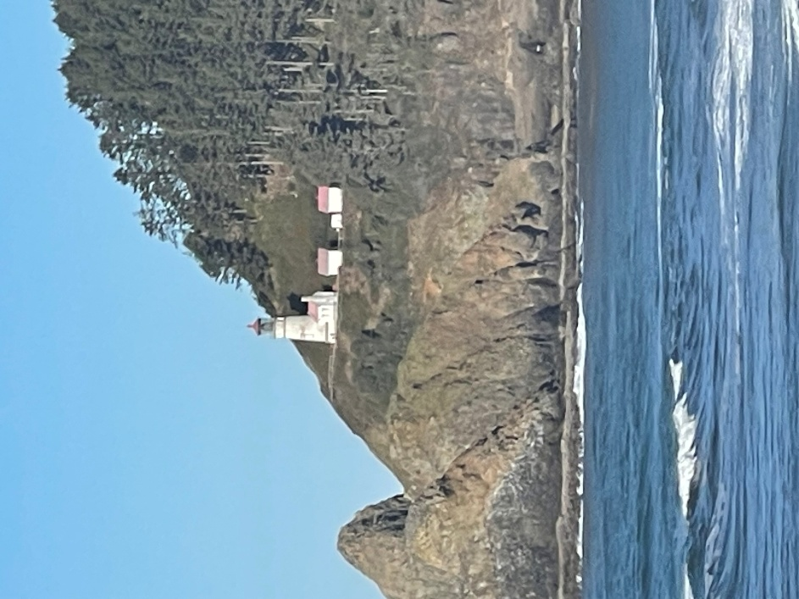
The selected image is a photograph taken at the Sea Lion Caves, featuring the Heceta Head Lighthouse in Florence, Oregon. The image was cropped to highlight the lighthouse and create a simplified composition.
Most of the buildings and their roofs will be comprised of boxes. The roofs would also be boxes, but rotated about the x-axis to achieve the roof's slant. The main building connected to the lighthouse would be a combination of the recently mentioned boxes and x-axis-rotated boxes, rotated slightly along the y-axis to obtain the building's side profile. This building also has a chimney, which can be recreated by inserting a thin cylinder into its side. The now-3D shape of the building connected to the lighthouse would be pushed into the tapered cylinder forming the lighthouse's base, creating a single building.
The lighthouse itself will be constructed as a tapered cylinder that forms the base. A cylinder can represent the light from the lighthouse. The lighthouse's roof will need a short cone with a cylinder layered on top.
The rocks on the far left-hand side will need to be tapered cylinders with a sphere layered on top to create the rounded top. The ground the lighthouse stands on would need to be a box tilted along the z-axis to create a slight slope; it will also need to be rotated on the x-axis to create the rest of the hill. Spheres will need to be embedded in the box, while a cone will need to be placed on the right-hand slope that creates the “V” shape in the rocks. This will be repeated for the portion of the hill/mountain that is behind the lighthouse. The trees, on the other hand, will need to be cylinders to create the trunks. My best guess for creating the branches and needles of the trees is a combination of small cylinders, prisms, cones, and spheres, layered on top of each other.

Resources
Grammarly. (2026, March 15). Clarity and correctness in writing [Spell check and grammar]. Grammarly. https://coda.grammarly.com/d/Tresch-2-3-Milestone-One-Project-Proposal-3-15-2026_dBVPQPJXieT/Tresch-2-3-20Milestone-20One-20Project-20Proposal-3-15-2026_suOhFE2v#_luN6Zf5z

